COLLEGE OF COMPUTER STUDIES DEPARTMENT
THESIS PROJECT
TITLE PROPOSAL
(CS0025 – Software Engineering 1)

Group Name: Statisfied | Program:  Bachelor of Science in Computer Science  with specialization in Data Science
Member’s Name:  1. Dawn Andrei Pamesa (Project Manager)  2. Rogelio Porras (Member 1)  3. John Ashley Alba (Member 2)  4. Ralph Blanco (Member 3) | Term:  [✓] 1st [ ] 2nd [ ] 3rd | Academic Year:  2026 - 2027
Proposed Project Title 3:
Screening Philippine Public Procurement Awards for Threshold Bunching and Digit Anomalies Using a Self-Baseline Modification of Benford's Law Tests

1.0 Area of Investigation:
Public procurement, the process where public budgets are turned into goods, works and services, and one of the main places where public money can be misused. In the Philippines, the purchases of agencies and local governments are recorded in the Philippine Government Electronic Procurement System (PhilGEPS). BetterGov, a volunteer-led civic technology group, republishes these records as open data, together with DPWH infrastructure contract data. Its PhilGEPS file holds 5,481,161 award rows, of which 2,467,462 distinct awards are dated 2021 to 2025 (retrieved 22 October 2026). No audit team can read this many records, so reviewers need a way to decide where to look first.
Benford's law gives one way to do this. In many naturally occurring financial data sets, the leading digit 1 appears about 30 percent of the time while the digit 9 appears under 5 percent. Numbers that people make up or adjust usually break this pattern, which is why digit tests have been used on public contracts in Brazil (Passos, 2026), municipal spending in Greece (Stefanou, 2026) and social welfare payments (Azevedo et al., 2021). Ensminger and Leder-Luis (2025) went further and built modified digit tests whose results matched a World Bank forensic audit of the same government-funded project. However, a recent mapping of 93 studies on procurement fraud detection found few real-world deployments and few public data sets (Schneider dos Santos et al., 2025). In the Philippines, Davis et al. (2024) used procurement contracts to measure corruption risk across provinces, yet no Benford-based screening of Philippine procurement was found.
Our preliminary analysis of BetterGov's PhilGEPS data (2,467,462 awards from 2021 to 2025, after removing exact duplicates) shows why a new method is needed. The amounts do not conform to Benford's law in any year, and the awards bunch strongly just below round amounts: about 14 awards fall in the 2 percent just below PHP 1,000,000 for every award in the 2 percent just above it. At the same time, the standard digit tests flag almost every large agency, which makes them useless for setting priorities. Agencies differ in what they buy and in how their budgets are set, so a test that compares every agency with textbook Benford will raise false alarms everywhere.
To conclude, the proposed system screens procurement awards in a way that is calibrated to this reality. Its main idea is to compare each procuring entity with its own past behaviour, and to test for extra bunching just below legal procurement thresholds. The system has five modules: (1) data ingestion and cleaning of BetterGov's public files; (2) feature engineering per agency and year (digit counts, rounding shares, and counts just below and above round amounts and legal thresholds); (3) screening tests, both standard and proposed; (4) an evaluation module that plants known manipulation into real data to measure false alarms and detection; and (5) a dashboard that shows each agency's digit and bunching profile with charts and plain-language explanations.
Algorithm/Technique Justification
Identified problem | Reviewers cannot read millions of procurement awards, and the standard digit tests flag nearly every agency on Philippine data.
Computational task | Detect agency-years whose award amounts show unusual digit patterns or extra bunching just below procurement thresholds.
Proposed algorithm/technique | Self-baseline anomaly detection built on Benford's law tests, which has a size-adjusted digit test with a practical tolerance, a test of each agency's digits against its own previous year, and a test of bunching below legal thresholds against the agency's own previous year and against placebo round amounts.
Reason for selection | Honest agencies differ from Benford's law and from each other, so comparing an agency with itself removes these structural differences. In preliminary tests on 388 real agencies, the self-baseline bunching test flagged 2 percent of agencies with no planted manipulation, while the standard fixed-cutoff test flagged 97 percent.
Required input/data | Award amount, award date, procuring entity and supplier per award (PhilGEPS via BetterGov, CC0); ABC and publication date if available; legal threshold schedules (GPPB issuances).
Expected output | A flag and an evidence summary per agency-year (digit deviation, bunching shift, comparison baseline), and a ranked review list.
Alternative algorithm | Fixed-cutoff MAD and chi-square (Nigrini, 2012, as cited in Azevedo et al., 2021); the all-digit-places and padding tests (Ensminger and Leder-Luis, 2025); contamination-corrected tests (Cerioli et al., 2019); positive-unlabeled learning with blacklisted suppliers as labels (Medina-Hernández et al., 2025).
Evaluation method | False-alarm rate at a 1 percent significance level; detection rate when known bunching is planted into real agency data at several strengths; year-to-year stability of flags; agreement with weak labels (GPPB blacklist); response to the RA 12009 threshold change; runtime.

2.0 Background and Rationale of the Project/System:
Procurement thresholds, the money limits that decide how a purchase is made. Under the 2016 Revised IRR of RA 9184, Small Value Procurement, which needs fewer steps than public bidding, was allowed up to PHP 1,000,000 for national agencies and up to amounts between PHP 50,000 and PHP 1,000,000 for local governments, depending on income class (Government Procurement Policy Board [GPPB], 2024). The same rules prohibit splitting contracts to avoid competitive bidding. RA 12009, the New Government Procurement Act, replaced RA 9184, and its IRR took effect on 25 February 2025 (GPPB, 2025), with a single quotation now enough up to PHP 2,000,000.
Thresholds give an incentive to set amounts just below them, and our data shows exactly this kind of bunching below round amounts. There are two explanations for it: the amounts were set to stay under a threshold, or the approved budgets were round and a bid cannot exceed the approved budget. A first placebo test separates the two for national agencies. From 2021 to February 2025, 91 percent of their awards near PHP 1,000,000 (their legal threshold) sat just below it, against 58 to 78 percent near other round amounts such as PHP 900,000, 2,000,000 and 3,000,000. The awards near the threshold were also more often repeat awards from the same agency to the same supplier within 30 days (38 percent against 22 percent near other round amounts), which is the pattern the rules on contract splitting target. Durtschi et al. (2004) warn that numbers with built-in maximums and numbers set by people often fail Benford tests for innocent reasons. A useful system must therefore tell these apart, not simply report that the data deviate.
The current tools have two weaknesses on data like this. First, the fixed conformity cutoffs depend on sample size, so they flag small samples by chance (Barney and Schulzke, 2016) and flag very large samples for tiny, harmless deviations (Cerqueti and Lupi, 2023). Second, they compare every agency with the same ideal pattern, although honest agencies differ. Cerioli et al. (2019), studying customs declarations, found that the digits of honest traders follow Benford's law only when a trader handles many different goods, and that the standard tests raise false alarms otherwise. A procuring entity also buys a limited range of things. The proposed system addresses both weaknesses: it adjusts for sample size, and it compares each agency with its own previous year and each threshold with nearby round amounts that are not thresholds.
A first test of this idea on the same data supports it. We ranked each procuring entity by how much more often its near-threshold awards form same-supplier clusters than its awards near other round amounts. The ranking is stable between 2021 to 2022 and 2023 to early 2025 (rank correlation 0.39 across 593 entities, and 0.35 after controlling for the number of awards), and it agrees with the share of awards just below PHP 1,000,000 (rank correlation 0.42 for 160 national agencies). Yet stable does not mean wrong, since an agency that keeps buying the same item from the same supplier scores high every year. The ranking is a reason to look, not a finding.
The key characteristics of the system are as follows: No fraud labels needed. It works without confirmed fraud cases. Evidence with every flag. Each flag shows which digits, which threshold and compared with what. Known false-alarm rate. It reports how often it would flag an honest agency by chance. The preliminary requirements are BetterGov's public data, the approved budget for the contract (ABC) and notice publication dates if BetterGov can provide them, and a Python environment. The focus is diagnostic screening of agency-years, and the desired outcome is a ranked, explainable list of agency-years whose award amounts changed in unusual ways, with a known false-alarm rate, for BetterGov and auditors to review.

3.0 Statement of Objectives:
General objective. To develop and evaluate, by the end of the second thesis term, a screening system that flags Philippine procuring entities whose procurement award amounts show unusual digit patterns or bunching below procurement thresholds, using a self-baseline modification of Benford's law tests on BetterGov's public data.
Specific objectives. The specific objectives are as follows:
1. To build a cleaned analysis data set of PhilGEPS awards from 2021 to 2025 with documented cleaning rules (date range, minimum amount, duplicate removal), and to engineer agency-year features: first-two digit counts, rounding and last-digit shares, and counts of awards just below and just above round amounts and legal thresholds.
2. To implement four standard tests (fixed-cutoff MAD, chi-square, size-adjusted MAD, and the all-digit-places test) and three proposed self-baseline tests (digit change against the agency's previous year, bunching shift against the agency's previous year, and bunching at legal thresholds against placebo round amounts), each with a size-adjusted significance level.
3. To evaluate all tests on simulated data and on real agency data with planted manipulation, measuring the false-alarm rate at a 1 percent significance level, the detection rate at three manipulation strengths, the year-to-year Jaccard overlap of flags, and the runtime on the full data set. The target is a false-alarm rate of at most 3 percent for the proposed bunching test on real agency pairs.
4. To test whether bunching responds to legal thresholds, by comparing real thresholds with placebo round amounts for each type of procuring entity, and by comparing bunching below PHP 1,000,000 and PHP 2,000,000 before and after 25 February 2025. To add a contract-splitting screen (awards just below a threshold, from the same agency to the same supplier within 30 days) and to show that its agency ranking is stable, with a rank correlation of at least 0.3 between 2021 to 2022 and 2023 to 2025.
5. To develop a dashboard prototype that presents each agency's digit and bunching profile with charts and explanations, and to evaluate its usability with BetterGov volunteers using the System Usability Scale.

4.0 Scope and Limitations of the Study:
Scope. The study covers PhilGEPS awards dated 2021 to 2025 as republished by BetterGov (CC0), with DPWH infrastructure contracts as a secondary source. The unit of analysis is the procuring entity per year, and award amounts of PHP 10 or more are analysed. The target users are BetterGov's team and the readers of its transparency tools. The system covers data ingestion and cleaning, feature engineering, the standard and proposed screening tests, the evaluation module and a dashboard prototype. The threshold analysis uses the Small Value Procurement schedules of the 2016 Revised IRR of RA 9184 and the RA 12009 single-quotation threshold.
Limitations. The limitations of the study are as follows:
Screening only. The system does not decide that fraud happened, and its flags are reasons to look, not findings.
No fraud labels. There are no confirmed fraud labels. The GPPB blacklist is used only as a weak check, because blacklisting is often for non-performance and expired listings are removed.
Approved budget. Unless BetterGov provides the ABC, bunching caused by round approved budgets cannot be fully separated from threshold avoidance. Award dates also stand in for publication dates.
Income class. The income class of each local government is not in the data, so every amount in an entity type's threshold schedule is treated as a possible threshold.
Amounts only. The study looks only at amounts, so it does not detect collusion between bidders, bid rigging that leaves amounts normal, or fraud that leaves no record.
Data errors. The source has errors (for example, award dates from 1920 to 2034), which are cleaned by documented rules but cannot all be corrected. No personal data are published, and supplier names are used only for matching and are not reported.

5.0 Target Beneficiaries:
The target beneficiaries are as follows:
BetterGov. The volunteer group that publishes the data. The system gives it a calibrated, explainable way to point readers and partners to agency-years worth a closer look, without accusing anyone.
Auditors and internal audit units. Commission on Audit teams and agency internal auditors can use the ranked list for audit planning, which is how Stefanou (2026) proposes digit tests be used.
Journalists and researchers. They get an open, reproducible method with a known false-alarm rate, instead of tests that flag every agency.
Procuring entities. Agencies can check their own records for patterns that may draw scrutiny, such as many awards just below a threshold.
Citizens and taxpayers. Better targeting of scrutiny supports a more accountable use of public funds.
Future researchers. The code, cleaning rules and evaluation design can be reused on other open procurement data.

6.0 SDG Category Number:
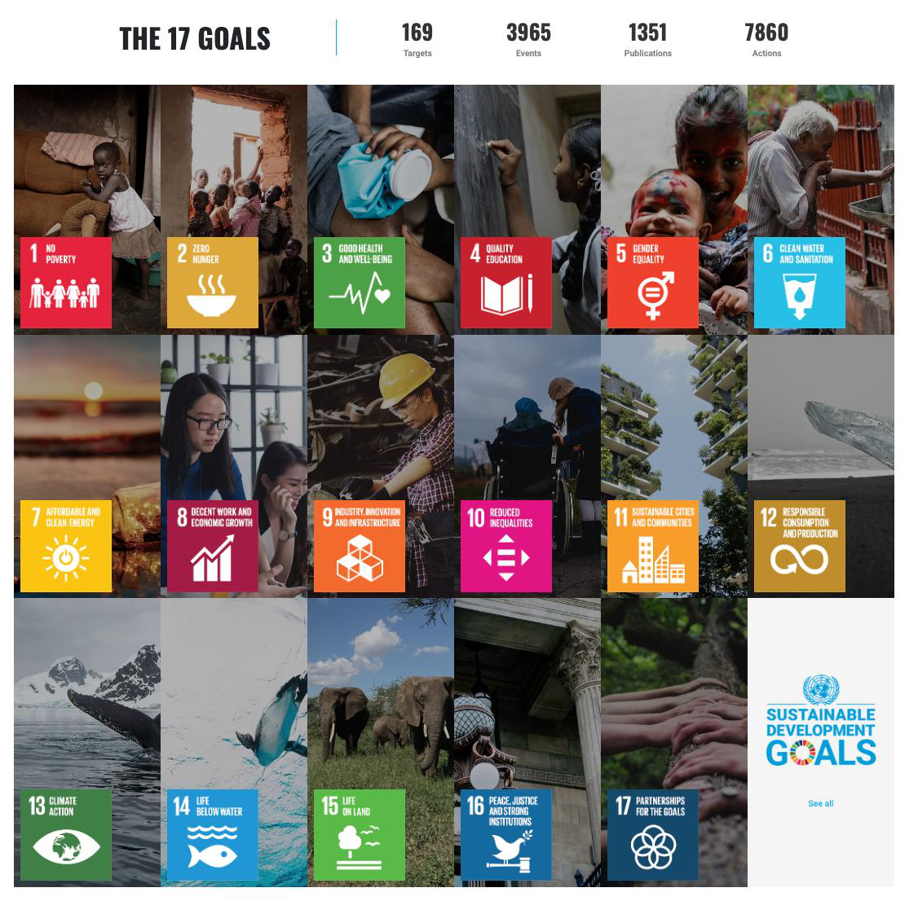
SDG Number: 16
SDG Title: Peace, Justice and Strong Institutions
Justification: SDG 16 includes targets to substantially reduce corruption and bribery in all their forms (target 16.5) and to develop effective, accountable and transparent institutions at all levels (target 16.6). The project supports both, since it turns open procurement data into a screening tool that helps civic groups and auditors focus scrutiny where award amounts behave unusually.

7.0 References:
Azevedo, C. da S., Gonçalves, R. F., Gava, V. L., & Spinola, M. de M. (2021). A Benford's law based method for fraud detection using R library. MethodsX, 8, 101575. https://doi.org/10.1016/j.mex.2021.101575
Barney, B. J., & Schulzke, K. S. (2016). Moderating "cry wolf" events with excess MAD in Benford's law research and practice. Journal of Forensic Accounting Research, 1(1), A66–A90. https://doi.org/10.2308/jfar-51622
Beber, B., & Scacco, A. (2012). What the numbers say: A digit-based test for election fraud. Political Analysis, 20(2), 211–234. https://doi.org/10.1093/pan/mps003
Cano-Rodriguez, M. (2025). How much is too much? Measuring divergence from Benford's law with the equivalent contamination proportion (ECP) (arXiv:2506.09915). Retrieved from https://arxiv.org/abs/2506.09915
Cano-Rodríguez, M., Núñez-Nickel, M., & Licerán-Gutiérrez, A. (2025). Divergence from Benford's law fails to measure financial statement accuracy. International Journal of Accounting Information Systems, 56, 100745. https://doi.org/10.1016/j.accinf.2025.100745
Cerioli, A., Barabesi, L., Cerasa, A., Menegatti, M., & Perrotta, D. (2019). Newcomb–Benford law and the detection of frauds in international trade. Proceedings of the National Academy of Sciences, 116(1), 106–115. https://doi.org/10.1073/pnas.1806617115
Cerqueti, R., & Lupi, C. (2023). Severe testing of Benford's law. TEST, 32(2), 677–694. https://doi.org/10.1007/s11749-023-00848-z
Cinelli, C. (2018). benford.analysis: Benford analysis for data validation and forensic analytics (Version 0.1.5) [Computer software]. Retrieved from https://CRAN.R-project.org/package=benford.analysis
Davis, D. B., Mendoza, R. U., & Yap, J. K. (2024). Corruption risk and political dynasties: Exploring the links using public procurement data in the Philippines. Economics of Governance, 25(1), 81–109. https://doi.org/10.1007/s10101-023-00306-4
Di Marzio, M., Fensore, S., & Passamonti, C. (2024). Validating Benfordness on contaminated data. Socio-Economic Planning Sciences, 95, 102008. https://doi.org/10.1016/j.seps.2024.102008
Durtschi, C., Hillison, W., & Pacini, C. (2004). The effective use of Benford's law to assist in detecting fraud in accounting data. Journal of Forensic Accounting, 5(1), 17–34.
Ensminger, J., & Leder-Luis, J. (2025). Detecting corruption: Evidence from a World Bank project in Kenya. World Development, 188, 106858. https://doi.org/10.1016/j.worlddev.2024.106858
Government Procurement Policy Board. (2024). The 2016 revised implementing rules and regulations of Republic Act No. 9184 (updated as of 19 July 2024). Retrieved from https://www.gppb.gov.ph/wp-content/uploads/2024/07/Updated-2016-Revised-IRR-of-RA-No.-9184-as-of-19-July-2024.pdf
Government Procurement Policy Board. (2025). Resolution No. 05-2025: Approving the circular providing policy guidance on Section 113 (transitory provision) in relation to Section 115 (repealing clause) of Republic Act No. 12009 and its implementing rules and regulations. Retrieved from https://www.gppb.gov.ph/wp-content/uploads/2025/10/GPPB-Resolution-No.-05-2025.pdf
Gridley, J., & Seneviratne, O. (2023). Significant digits: Using large-scale blockchain data to predict fraudulent addresses (arXiv:2301.01809). Retrieved from https://arxiv.org/abs/2301.01809
Kössler, W., Lenz, H.-J., & Wang, X. D. (2024). Some new invariant sum tests and MAD tests for the assessment of Benford's law. Computational Statistics, 39(7), 3779–3800. https://doi.org/10.1007/s00180-024-01463-8
Medina-Hernández, M., Kertész, J., & Fazekas, M. (2025). Learning from sanctioned government suppliers: A machine learning and network science approach to detecting fraud and corruption in Mexico (arXiv:2512.19491). Retrieved from https://arxiv.org/abs/2512.19491
Passos, L. (2026). The application of Newcomb-Benford's law in detecting anomalies in public contracts of the State of Rio de Janeiro. RECIMA21 - Revista Científica Multidisciplinar, 7(8). https://doi.org/10.47820/recima21.v7i8.8711
Schneider dos Santos, E., Machado dos Santos, M., Castro, M., & Tyska Carvalho, J. (2025). Detection of fraud in public procurement using data-driven methods: A systematic mapping study. EPJ Data Science, 14(1), 52. https://doi.org/10.1140/epjds/s13688-025-00569-3
de Araújo Silva, A., & Aparecida Gouvêa, M. (2023). Study on the effect of sample size on type I error, in the first, second and first-two digits ExcessMAD tests. International Journal of Accounting Information Systems, 48, 100599. https://doi.org/10.1016/j.accinf.2022.100599
Stefanou, G. (2026). Benford's law as a tool for audit planning and control: An analysis of municipal expenditures. INTOSAI Journal. Retrieved from https://intosaijournal.org/journal-entry/benfords-law-as-a-tool-for-audit-planning-and-control-an-analysis-of-municipal-expenditures/

Approved by:

______________________
Panel Member 1 / Date

______________________
Panel Member 2 / Date

Noted by:

___________________________
Thesis 1 Course Adviser / Date

1. AI Interaction Log (if applicable)
If your group used any Generative AI tool while completing the assessment, document how the tool was used. The log should demonstrate that AI supported the group’s work rather than replacing the group’s research, analysis, and decision-making.
Group Member | AI Tool Used | Prompt / Purpose | AI Output Used For | How the Output Was Verified or Modified
Dawn Andrei Pamesa | Claude (Claude Code) | Asked Claude to read the public BetterGov PhilGEPS files, run the digit and threshold tests, draft this proposal in the structure of the official template, check every reference against Crossref, arXiv or publisher records, and format the document in the official layout. | Analysis scripts and their results, a first draft of every section, reference checking, and formatting. | References were checked against their original records, and the numbers come from scripts in the group's repository that anyone can re-run. The group wrote most of the text itself. The text was rewritten in the members' own words and checked against the sources.
Rogelio Porras | Codex | Used Codex to help draft the review of related literature (RRL). | A draft of the RRL. | Ralph Blanco and John Ashley Alba verified the RRL and RRS against the sources.
John Ashley Alba | None used | N/A | N/A | N/A
Ralph Blanco | None used | N/A | N/A | N/A

2. AI Usage Declaration
We declare that any use of Generative AI in completing this Technical Assessment has been properly disclosed in the AI Interaction Log. We understand that AI is used only as an assistive tool and that our group remains responsible for verifying the accuracy, relevance, credibility, and originality of the submitted work.
We confirm that the final title proposal, objectives, scope, algorithm justification, and research outputs reflect our group’s understanding and decisions. All literature, studies, and other external sources used have been properly cited and verified.
Group Name: Statisfied
Date: October 24, 2026
Group Member | Signature
Dawn Andrei Pamesa
Rogelio Porras
John Ashley Alba
Ralph Blanco

3. Team Contribution Matrix
The total contribution percentage must equal 100%.
Group Member | Assigned Task/Responsibility | Specific Contribution/Output | Contribution (%)
Dawn Andrei Pamesa | Project Manager; Researcher | Ran the BetterGov analysis and the reference checks, and wrote the first draft of the title proposal with Claude. | 30%
Rogelio Porras | Researcher | Wrote the review of related literature (RRL), drafted with Codex. | 24%
John Ashley Alba | Researcher | Verified the RRL and RRS and helped with the initial title proposal. | 23%
Ralph Blanco | Researcher | Verified the RRL and RRS and helped with the initial title proposal. | 23%
 |  | Total | 100%

